Dear Diary,

I am on the plane right now. I am so excited to start my new life in Germany at Leuphana. The process that took to get my visa was very hectic, but I am very glad to be here. The plane is quiet right now and most people are asleep. My outfit for my first day of uni has already been planned. It does feel odd to be leaving my family and my whole life behind. Of course, I am excited to start my new life but it is scary to be a teenager moving to the other side of the world. I wonder what friends I’ll make, if I will fit in. I must get a German SIM card and call my mum as soon as I get there. I am lucky, there will be someone to get me at the airport. I spent my time writing poetry dedicated to this process today. Let me get some sleep before the plane lands.

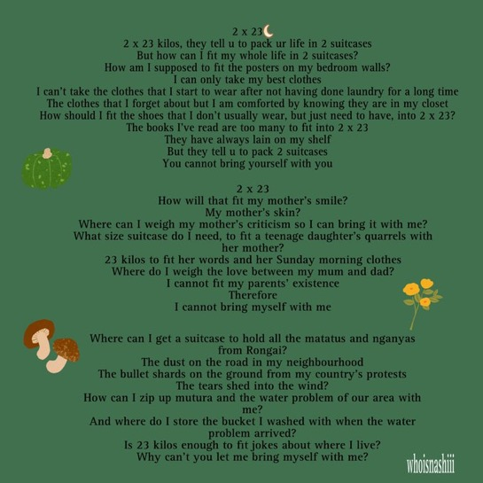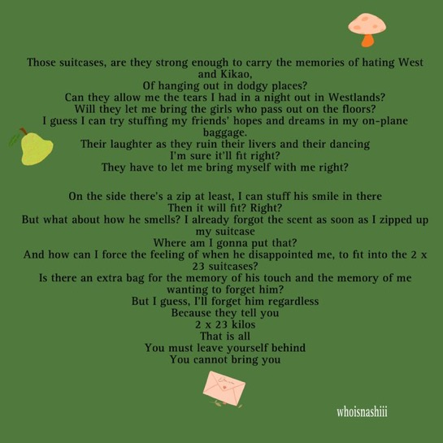

- Xoxo international student

